 

Measuring bird diversity on NDL campus

Technical specifications

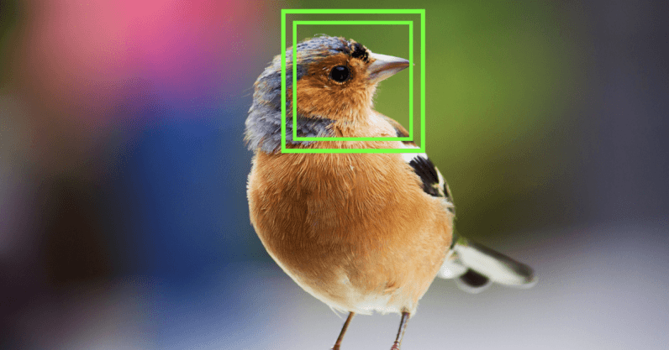

***Eileen MORGUE, Ulysse MERAD, Matthew LE BOUFFOS***

**Year 2023/2024** **Institut Supérieur d’Électronique de Paris**

**Table of contents**

Overview 3

1.1 Problem statement 3

1.2 Aims and objectives 3

1.3 Scope 4

Technical specifications 6

2.1 Introduction 6

2.2 Equipment specifications 6

2.3 Hardware specifications 10

2.4 Software specifications 15

A) Image taking and sending process 16

B) Identification process with artificial intelligence 16

C) Data storing process 17

D) Data showing process 18

Conclusion 21

Annex 22

Project schedule 22

Job breakdown 23

# Overview

## 1.1 Problem statement

It is often difficult for researchers to accurately study bird biodiversity within a specific area without the use of RFID tags to recognize the birds. Traditional techniques imply that the birds are captured in order to place RFID tags on them to be able to distinguish individual birds when they come back later. In urban areas such as the city of Issy-les-Moulineaux, the feasibility of this is very low, and researchers lack detailed information about the bird population other than knowing which bird species can be found at Issy-les-Moulineaux after having previously taken pictures of some of them.

Intelligent bird feeders and bird nests are an innovative solution to tackle this issue. They can attract birds passing by and looking for food (bird feeders) but also birds who want to nest during the reproductive season (bird nest boxes). They are intelligent in that they have cameras installed inside them or pointing at the entrance which allow for picture-taking of all bird species entering them. These images can then be analysed by artificial intelligence in order to identify bird species and collect relevant data to study the biodiversity at Issy-les-Moulineaux.

## 1.2 Aims and objectives

First and foremost, the aim of our project is to identify the different bird species in the surrounding areas of the ISEP campus in Issy-les-Moulineaux, close to Paris. The kick off date of the project is expected to be in January/February 2024. The monitoring period will take place over a time period to be defined but should at least cover the nesting period (Spring 2024).

To do so, we plan to install cameras in bird nest boxes and in bird feeders. Artificial intelligence (AI) will be used to identify the different bird species.

The data will be collected, transmitted to a central server and analysed to offer relevant information about the biodiversity around the area of the campus of Institut Supérieur d’Electronique de Paris (ISEP) at Issy-les-Moulineaux. It will then be sorted, organised and displayed on a screen in the hall of the campus to make it educational: students will be able to learn real facts about birds (“Did You Know?” facts).

Statistics with pictures and images will be displayed on an attractive and engaging dashboard. The optimal version of the software will have a database which can be used to display information on the screen as well as on a website.

To achieve these objectives will require close collaboration with the Ligue pour la Protection des Oiseaux (LPO) organization. They will be providing us with bird nest boxes and bird feeders for our school, and help us install them on the ISEP campus.

The school will take over the project after us due to our departure abroad starting from February 2024.

## 1.3 Scope

Technical context

The overall goals and objectives of the project are to collect, analyse and share data relating to the bird frequentations on the Issy-les-Moulineaux campus over a defined time period (to be defined) to enable interested parties to evaluate the bird species diversity in this area.

Data collected within the project scope would include date and time of passage, location within the campus and identification of the bird species.

To attract the birds, we would need bird nesting boxes and bird feeders.

To collect data, we would need cameras to record their passage, which would be placed either outside (directed towards trees and nesting boxes) and/or inside the bird feeders and nesting boxes.

To analyse the data, we would use both artificial intelligence and possibly at the beginning human intervention to train it.

Data sharing would be done via low-energy radio transmission from the cameras to the ISEP servers. An automatic database will be implemented with all the information gathered and will be used to create a dashboard with statistics and facts about birds located in the surrounding areas of the campus.

Main constraints

Accuracy of the data collected will depend on the conditions of the picture-taking: luminosity, angle, picture quality, and an extensive data set to train our AI.

As the birds are not tagged, the same bird could come in and out multiple times and therefore skew the frequentation data.

The budget and time constraints could limit the overall accuracy of data collected as the training of the AI is very time and energy consuming, as well as the sorting and selection of good quality pictures to feed the AI’s data bank.

Some of the trees on the campus are protected by nature conservation laws, therefore we cannot install bird nest boxes or bird feeders on them. This, coupled with the fact that birds prefer having their nests oriented towards the east to be awakened by the sun rising, limits the choice of suitable locations to install the equipment.

Birds want to have nests that are clean, therefore the nests must be cleaned between two nesting periods. Furthermore, bird feeders should be cleaned and replenished regularly (every week or so) to attract birds.

Nocturnal bird visits will make it difficult to identify individual species due to a lack of luminosity, although infrared pictures may partially tackle this issue. Another possibility would be to record the bird chirping/singing. However, this implies the transmission of more voluminous data compared to images only and would require us to reflect on how to “zip” the volume of data transmitted.

Once the nests have been installed and birds are nesting in them, it is not possible or advisable to touch them, so any solar-powered battery will have to be optimally positioned outside the nests for easy access and to capture solar energy.

The battery unit cost will be impacted by the fact that it must be rugged, weatherproof and long-lasting.

A low energy transmission protocol is mandatory because, if not, the batteries will discharge too quickly considering the amount of data to be regularly transmitted.

Our lack of technological know-how related to the technology deployed may impede our ability to accurately monitor, record and analyse the data.

Consequently, the above constraints may impede the accuracy of the monitoring results.

# Technical specifications

## 2.1 Introduction

In order to carry out the project efficiently, various types of equipment are required. This equipment can be divided up into 3 main categories: equipment and supplies, hardware equipment and software.

## 2.2 Equipment specifications

Bird nesting boxes

Requirements are for a total of four different nesting boxes to be supplied by the Ligue pour la Protection des Oiseaux (LPO) organization. The placement of these nesting boxes will depend on optimizing the height and orientation based on which species we want to attract.

The exact models to be supplied are as follows:

**Robin nesting box kit (x1)**

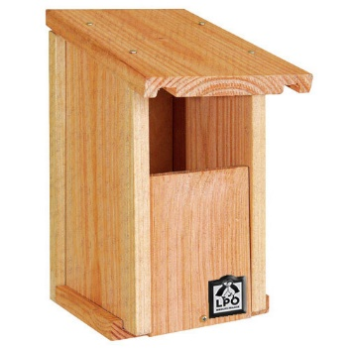

Link: [Nichoir Rougegorge en kit | Boutique LPO](https://boutique.lpo.fr/produit/JO0217)

Example of expected bird species: robin, black redstart, white wagtail and spotted flycatcher

**Half-open nordic nesting box kit (x1)**

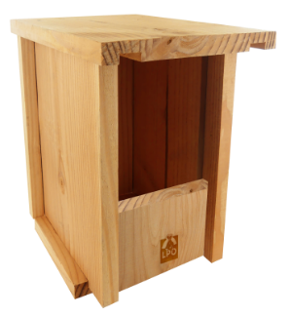

Link: [Kit Nichoir Nordique Semi-ouvert | Boutique LPO](https://boutique.lpo.fr/produit/JO1051)

Example of expected bird species: robin and winter wren (if placed less than 2 meters from the ground) or white wagtail and spotted flycatcher (if higher but less than 4 meters)

**LPO majestic nesting box kit (x1)**

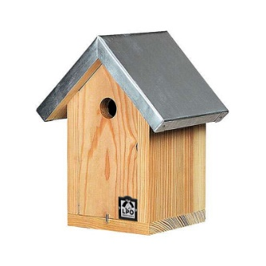

Link: [Nichoir Majestic LPO | Boutique LPO](https://boutique.lpo.fr/produit/JO1060)

Example of expected bird species: sparrows, wood nuthatch and great tit

**28 mm mountainous nesting box kit (x1)**

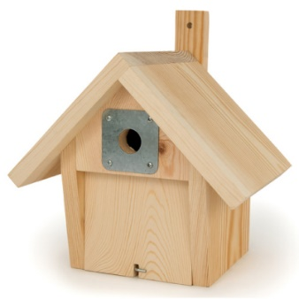

Link: [Nichoir Montagnard 32 mm nouveau modèle | Boutique LPO](https://boutique.lpo.fr/produit/JO0902)

Example of expected bird species: tree sparrows, house sparrow, great tit and wood nuthatch

Material to attach the nesting boxes includes the following: aluminium nails, anti-predator guards, rope, glue, string, etc.

Bird feeders

**Option 1**

The bird feeders will be made to measure by the MakerLab of ISEP using the 3D printer available at the school. The materials used will be transparent to optimise luminosity and clearly reveal food supplies to attract the birds.

An example of what our bird feeder could look like is as follows:

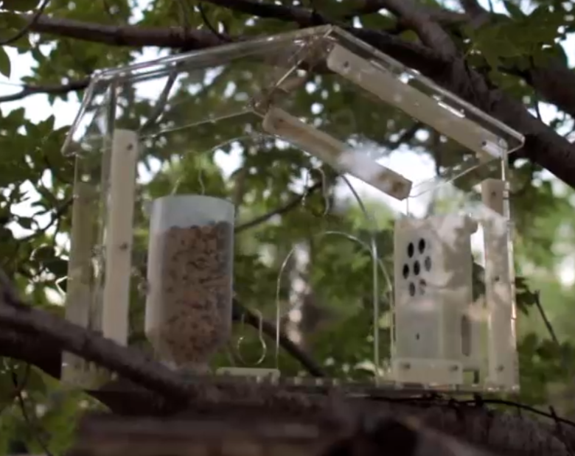

There will be three bird feeders in total.

The bird feeders will be attached using string, rope, rings, etc.

**Option 2**

Alternatively, we could use traditional bird feeders supplied by LPO with cameras placed outside and pointing towards them.

Examples include:

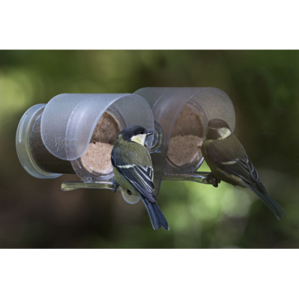

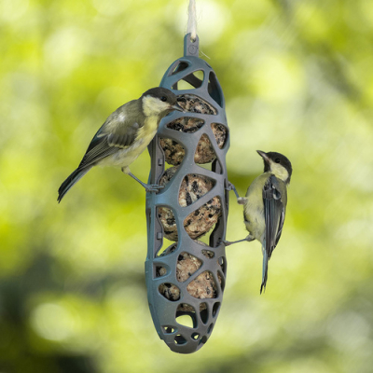

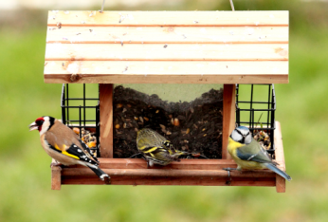

They will be placed on the branches of the trees, ideally positioned to avoid predators and squirrels whilst also being visible. To be cleaned and replenished regularly, they must be safely accessible using a stepladder that can be securely and safely positioned.

The bird food would include sunflower hearts, peanut butter blocks and peanuts, fat balls and squares, dehydrated worms and mixed seeds. Estimated cost per month will not exceed a hundred euros. Replenishment must take place minimum once per week.

Finally, the bird feeders will be able to potentially attract bigger birds than the bird nesting boxes, therefore offering us a diversified data set for studying the bird species in Issy-les-Moulineaux.

Bird troughs

It can be difficult for birds to find water during winter. Therefore, two bird troughs will be installed within the grounds.

Example

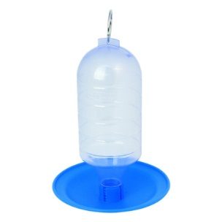

It must be positioned at a height to attract birds but free from predators and easily and safely accessible by stepladder for replenishment. Replenishment must take place minimum once per week.

Miscellaneous supplies

To attach the nesting boxes, bird feeders and bird troughs, we will be using rope, scotch, string, nails, glue, etc. The equipment will either be attached to the trees directly using nails or connected to them and hanging from them using string and else. Another option would be to install wooden pillars in the ground and place nesting boxes, bird troughs or bird feeders on top. Cleaning products will be required to thoroughly clean the equipment between seasons for the nesting boxes or more frequently every month or two weeks for the troughs and feeders. The overall estimated cost of miscellaneous supplies should not exceed three hundred euros.

## 2.3 Hardware specifications

Hardware encompasses all the electronic equipment that will be installed either inside or outside the nesting boxes and bird feeders, depending on the specific conditions (internal space available, ideal luminosity, impermeability, etc.) If the equipment needs to be installed outside and exposed directly to the elements, they will need to be protected.

For each picture-taking equipment, we will associate a lens/camera module with a data sending device (micro-controller or mini computer), an antenna and a solar-powered battery. There will be at most ten of these kits, in order to take pictures in the four nesting boxes, the three bird nests, and from three different angles outside.

Lens/camera module (x10 maximum)

The lens used will be determined according to its location and luminosity levels. Infrared cameras may also be an option inside the nests in case of low luminosity and nocturnal bird passages. We must consider the angle and distance of capture.

It shall be connected to the data sending device, and the exact models will be determined once we choose our exact solution.

Example of a camera module for Raspberry Pi 5:

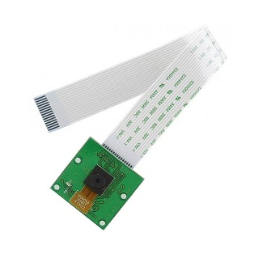

Link: <https://www.gotronic.fr/art-module-camera-5-mpx-b0033-24876.htm>

Data sending device (x10 maximum)

We need a data sending device that can transfer data using any protocol such as Wi-fi, the LoRa network or 3G. Our protocol of choice must consume very little energy in order to have a battery that will last for long.

Depending on what we want for our data sending device, we have two options.

Option 1

The data sending device is a micro-controller, and it can only execute effectively one task. It cannot receive any information, therefore it will not be able to perform supplementary actions other than sending to the servers the pictures that have been taking. The advantage is that the energy consumption will be lower than a mini computer, and it will also be more efficient by only doing the exact same task of sending images to the server.

Consequently, there are two choices of models:

**Texas Instrument Launchpad**

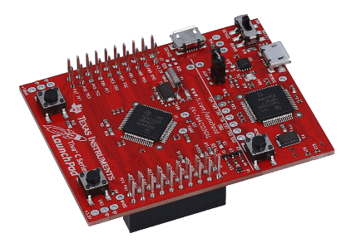

Link: [EK-TM4C123GXL Evaluation board | TI.com](https://www.ti.com/tool/EK-TM4C123GXL)

**Arduino MKR WAN 1300 (LoRa network)**

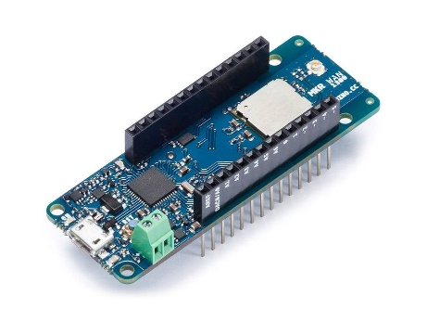

Link: [Carte Arduino MKR WAN 1300 (Zero + Lorawan) (yadom.fr)](https://yadom.fr/arduino-mkr-wan-1300.html)

Option 2

The data-sending device is a minicomputer which means that it can perform multiple tasks. It can both send and receive information. One supplementary task that we have been thinking about is the detection of disruptive species such as squirrels and rats. If ever those are detected, the server can send a signal to the data-sending device in order to activate a deterrent noise. This will prevent the food from being eaten by species that are not birds. The advantage of this solution is that we can perform multiple tasks and more in-depth tasks, which would allow us to get better monitoring results. However, the energy consumption will be higher than a micro-controller.

One model that we could use is the famous Raspberry Pi 5.

**Raspberry Pi 5**

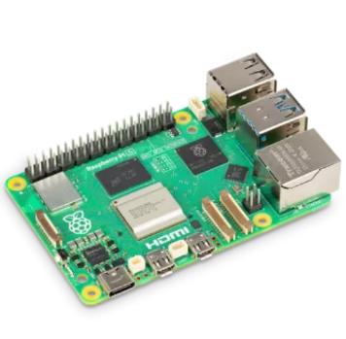

Link: [Carte Raspberry Pi 5 4GB, 8GB (kubii.com)](https://www.kubii.com/fr/nano-ordinateurs/4106-1831-raspberry-pi-5-3272496315938.html#/ram-4_gb)

Antenna (x10 maximum)

Each data-sending device will have an integrated antenna or small equipment in order to send data. Therefore, we will be choosing a model depending on the frequency and protocol we want to use.

Battery (x10 maximum)

Each data-sending device coupled with a camera will be connected to a solar-powered battery. It will be at least 10 000 mAh and waterproof.

**Example of a solar-powered battery**

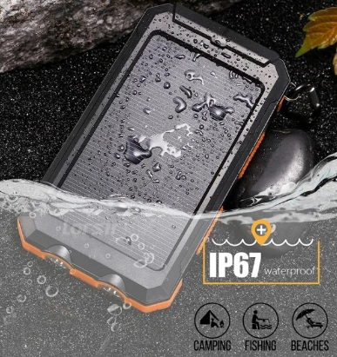

Link: [Solar-powered battery](https://www.aliexpress.us/item/3256804060789139.html?spm=a2g0o.productlist.main.13.796e6341mBZZbe&algo_pvid=1be21364-4909-4a91-aa98-ec41ecef39df&aem_p4p_detail=202310090459101308097236496120002089440&algo_exp_id=1be21364-4909-4a91-aa98-ec41ecef39df-6&pdp_npi=4%40dis%21EUR%2116.05%2112.04%21%21%2116.56%21%21%4021038edf16968527502992520ef419%2112000028513019836%21sea%21US%210%21AB&curPageLogUid=UvQ62eVoB0Mm&search_p4p_id=202310090459101308097236496120002089440_7)

Bird detector (x7 maximum)

Birds will be detected using movement detection devices. We will be using wired pressure sensors placed at the entrance of the nesting boxes and bird feeders or inside them, coupled with discrete PIR sensors inside them or next to them. The exact models are to be determined once we have bought our data-sending devices in order to have compatible devices.

**Example of a wired pressure sensor**

**Example of a PIR sensor**

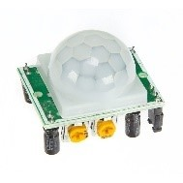

## **2.4 Software specifications**

# Edge Computing

In order to fit with the local use of our project and to remain the more independent our system architecture will be on edge. Meaning that everything, including calculations and data storage is going to be local, on our servers.

An interrogation was the choice of an environment and programming language to run our 4 services**:**

* **image receiving,**
* **image classification**
* **data storage (including images)**
* **final display of the analysis.**

For convenience we prefer to encapsulate each service to be able to fix bugs or improve each individually.

Our project focuses on machine learning computer vision, a very large subject in which we can easily be overwhelmed. The choice of language, framework and libraries should be strictly defined by efficiency.

Yet, we do not know which application server is the most suited. And if one is necessary. An approach would consist in running

### **Image taking and sending process**

Because we are limited by power consumption a light program is mandatory. It will consist by detecting movement, take a picture and sent it via the MQTT protocol to a broker.

Eather a microcontroller programmed in C is enough or a light raspberry pi.

**Flowchart**

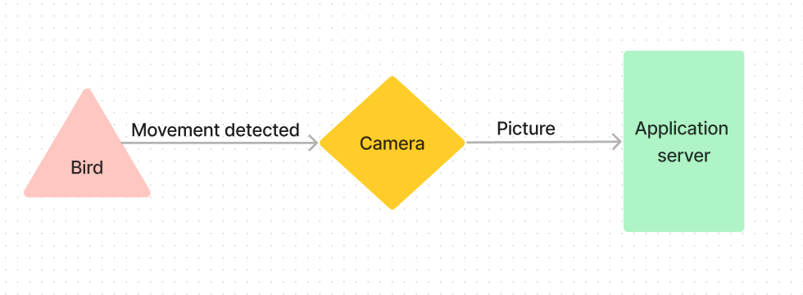

**Server side**

### **Identification process with AI Computer vision Model**

**General description**

A lot of ML libraries exist for Python a language accessible to us. Our choices converge indeed on python friendly libraries.

Choice of Image Classification model and service

* TensorFlow (Google) MobileNetV2 bird model (
  + [TensorFlow Hub](https://tfhub.dev/google/aiy/vision/classifier/birds_V1/1)
  + 900 species from iNaturalist dataSet
  + already trained model and ready to use
  + able to learn even more species if we want to teach it
  + suited very well with Coral AI
* OpenCV (OpenSource)
  + [Home](https://opencv.org/)
  + free largest image processing library
  + need to build our own model by creating a dataset and

The final program will have both TensorFlow and OpenCV running. OpenCv providing image resize and cropping to fit well for classification with TensorFlow. The TF mobileNEt Bird model is very relevant, an accurate model pre-trained for birds that we can enhanced with our own set.

**Flowchart**

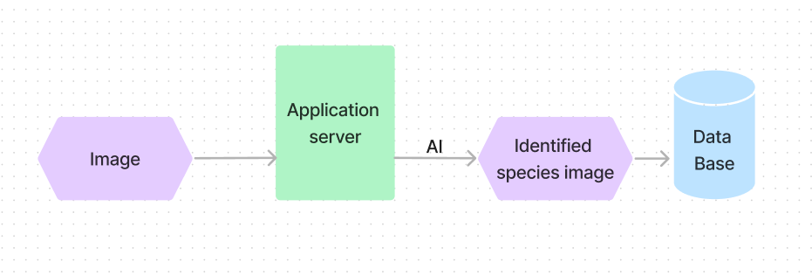

### **Data storing process**

**General description**

Choice of a data base service

💡 Main consideration point here is to have a DB well suited for saving large binary files such as images.

* MySqL
  + Large and easy to manipulate but complex for image
* MongoDB
  + NoSQL ⇒ better for image
* Think to use of Blob (Binary large object)
  + interesting if we use a SQL Db

MongoDB is very interesting because of its capabilities for image storage that do no need BLOB.

We don’t know how to transfer data between our services and what is the best road for the images. Should we first save them then access to it with for processing or directly sent it to processing then save it with metadata result.

**Flowchart**

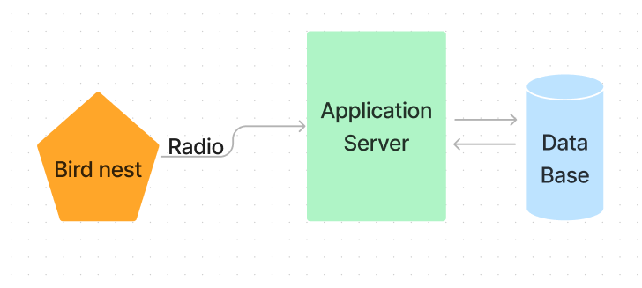

### **Data Display**

**General description**

Certainly, a React web app accessing data from the database using API endopoints.

Streamlit is also interesting because of its python integration. It is designed for data science visualization with a lot of possibilities.

# Conclusion

One of the major issues to be considered is how we manage the data in terms of protocols used, time conservation policy, server capacity, data transfer speed.

With respect to the exact location of the bird feeders: a major consideration is that some trees are protected so we cannot install bird feeders on them. There may be a possibility to install bird feeders on the entrance gates if authorised to do so by ISEP. Alternately, wooden pillars could be placed and bird feeders positioned on top of them. The nesting boxes and feeders will be placed at different heights to attract a wide variety of bird species because some birds eat near to the ground and others higher up.

As birds not only seek food but also water, especially during the winter months, bird troughs should attract more birds during these months.

It is essential to note that ISEP staff regularly replenishes both the bird feeders and bird troughs in order to attract as many birds as possible.

Each datum transferred has a certain volume and thus consumes a certain quantity of energy. As we would like the batteries to be long-lasting, we shall have to evaluate the transfer cost of an image and or a bird chirp/song. The choice of the image quality, the number of pictures taken will be made based on these results.

The transmission protocol and mode will be selected based on the bandwidth, energy consumption rates, frequency, efficiency, ease of use, compatibility, etc.

Some data sending devices can use Wi Fi but others cannot for example the Arduino microcontroller can use Wi Fi but other models of microcontrollers are unable to do so.

The LoRa network can be a good choice however it can only transmit 140 files per day (in other words 140 pictures).

If we decide to implement deterrent sounds (anti-predators), we will be unable to use a microcontroller because the microcontroller can only carry out one task at a time: it must be either sending or receiving data.

The main database will be a timestamp value database.

To conclude, our project will be using the local servers of ISEP.

# Annex

## Project schedule

1) 16/10 - Object model

2) 06/11 - Coding of the object model

3) 13/11 - Coding of the object model (continuation)

4) 20/11 - Autonomy (submission of the code of the model)

5) 27/11 - Testing and finalisation

6) 04/12 - Autonomy (preparation of the defense)

## Job breakdown

|  |  |  |  |  |  |  |  |  |  |  |  |  |  |  |
| --- | --- | --- | --- | --- | --- | --- | --- | --- | --- | --- | --- | --- | --- | --- |
| Job lot | | | | | | | | | Person Responsible | | | Deadline | Status and comments | |
| Finalise and validate technical specifications | | | | | | | | | All | | | October 2023 | * Define exact budget | |
| Define exact location of nesting boxes, feeders and troughs | | | | | | | | | All | | | October 2023 | * Decision to be made if wooden pillars are to be used and how the feeders will be attached (trees, gates or on top on pillars) * Define if ISEP will make the feeders | |
| Define and finalise protocols | | All | | | | October 2023 | | | * Protocols related to data transmission, application server, screen display... | | | | | |
| Start creating and training AI tool | | | | | Eileen, Ulysse | End October/beginning November 2023 | | | * Use of a ready to use AI tool and adding of new images to it to enhance its abilities | | | | |
| Select and program server | | | | | Ulysse | November 2023 | | | * Application server should be able to process information and automatically create tables from which information will be extracted | | | | |
| Define dashboard display | Ulysse, Matthew | November 2023 | | | * Display should use extracted information and be educational and attractive | | | | | | | | |
| Contact LPO to agree on supplies of the boxes, price + delivery and leadtimes | | | | | | | | | Eileen | | | November 2023 | * Possibility of customised bird nesting boxes | |
| Select potential suppliers and demande quotes (price (cost + delivery) and leadtimes | | | | | | | | | Matthew | | | November 2023 | * Hardware equipment will be purchased once nesting boxes models have been finalised and dimensions are known | |
| Receive and control cameras | | | | | | | | | All | | | December 2023 | * Cameras and batteries will be delivered to ISEP | |
| Position cameras and batteries and test functionality | | | | | | | | | All | | | December 2023 | * In the case of different models, ensure cameras are installed in optimal positions | |
| Test data transmission | | | | | | | | | Eileen, Ulysse | | | Beginning January 2024 | * Manual review of images transmitted, see if any adjustment is needed | |
| Test data sorting | | | | | | | | | Matthew | | | Beginning January 2024 | * Manual review of the sorted data | |
| Final testing and fine tuning | | | | | | | | | All | | | January 2024 | * Any major bug corrections and improvements are to be made at that point | |
| Launch | | All | | | | February 2024 | | | * Decision to be made on how the launch will take place | | | | | |
| Issue instructions for cleaning, replenishing bird feeders and bird troughs | | | All | | | | February 2024 | | | * To be precisely defined | | | | |
| Issue instructions protocols for data control and management | | | | All | | | | February 2024 | | | * To be precisely defined | | | |